# 

# Triangular Arbitrary

### Your new one stop shop for tracking stocks and cryptocurrencies

**CSC 436 - Group 6**

Mitchell Ergen

Eric Haerr

Kevin Lineback

Kevin Looft

Tyler Reed

## Overview

As a stock and cryptocurrency tracking application, The Triangular Arbitrary web app will allow users a simple and focused method for monitoring their investments. Users are able to choose their favorite stocks and see realtime values. They can also see the value of their favorite cryptocurrencies. System admins are available 24/7 to provide support for account management as well as monitoring for fraudulent activities.

## Requirements

### Use cases

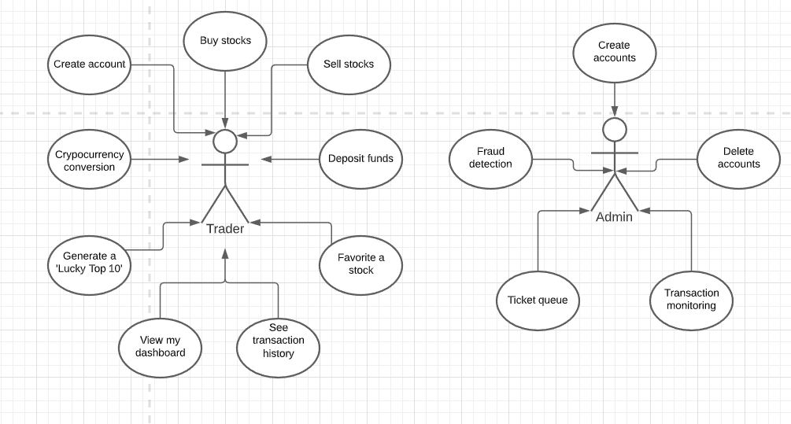

### Persona definitions

**Persona 1: Danny “Day Trade” Hughes**

Danny is a thirty-two-year-old male. He lives with his fiancé in an apartment in Chicago. Danny holds an undergraduate degree in Finance and a Master of Business Administration degree. He works for a FinTech company. After work, Danny spends time at home with his fiancé. On the weekend, Danny prefers to go out with friends. Danny and his fiancé want to save money for a down payment on a house in the suburbs.In order to help save money, Danny has turned to day trading on the stock market. He is familiar with trading basics from his degree and his job. Danny primarily trades in between meetings and on his morning, afternoon, and lunch breaks at work. He has invested in a small number of volatile stocks that he plans to sell when the share price increases. Additionally, he has invested in a few cryptocurrencies. Danny needs a way to track the stocks and cryptocurrencies he has invested in. Danny spent time looking for a webapp that will suit his needs.He comes across a webapp called Triangular Arbitrary. Danny creates an account and sets his preferences. He searches for some of his current investments and adds them to his favorites. He now has an easy method of tracking his stock and cryptocurrencies. He also frequently reviews the I’m Feeling Lucky Top 10 list for new potential investments. Danny is now able to make faster decisions regarding when it is time to buy and sell his investments.

**Persona 2: Adam the Admin**

Adam is the administrator for our application, he is a jack of all trades when it comes to system administration. He works from home and is responsible for the upkeep, configuration, and reliable operation of the system. Apart from overall system monitoring, Adam spends most of his time helping customers reset their accounts after being locked out from entering too many incorrect passwords. He monitors and takes actions upon support tickets from end users. On occasion, Adam will have to take the system down at 4 AM to perform patching or updates. Adam is also in charge of security and monitors for fraudulent accounts and other potential threats to the system.

### External service integration

Our application is planning on utilizing multiple external services. The primary source of data will come from Alpha Vantage. These api endpoints will provide the necessary data to drive the application's core functionality. Data endpoints include stock and company data and cryptocurrency exchanges for traders who wish to trade in cryptocurrencies. For example, if a trader would like to know the value of their cryptocurrency in US dollars our application will submit the following request to Alpha Vantage:

<https://www.alphavantage.co/query?function=CURRENCY_EXCHANGE_RATE&from_currency=BTC&to_currency=USD&apikey=demo>

The api parameters in this case are:

|  |  |
| --- | --- |
| function | specify the endpoint's function |
| from_currency | Starting currency |
| to_currency | Converted currency |
| Api key | Our group’s key |

We are also currently looking into other integrations including the use of persistent data options. The likely provider being Firebase.

Another external service we will consider using is Google Analytics. In the course we will be spending a chunk of time devoted to analyzing the who, the what, and the why of our application’s use for end users. We do that up front before building and deploying our product. Use of Google Analytics gives us the ability to measure those initial assumptions through end user interactions. The results will allow us to plan and make adjustments for successive iterations of the application.

## Screenflow

Screen design hosted here: <https://whimsical.com/PFkrZqnSxrZdYnqzKsaJXT>

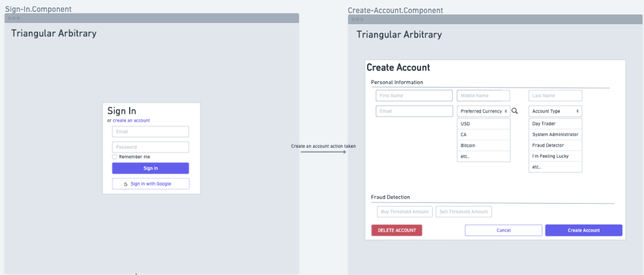



**Components**

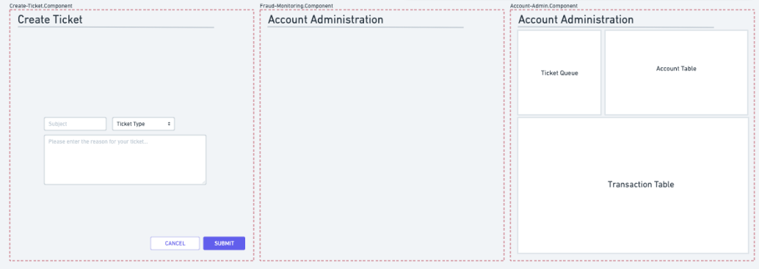

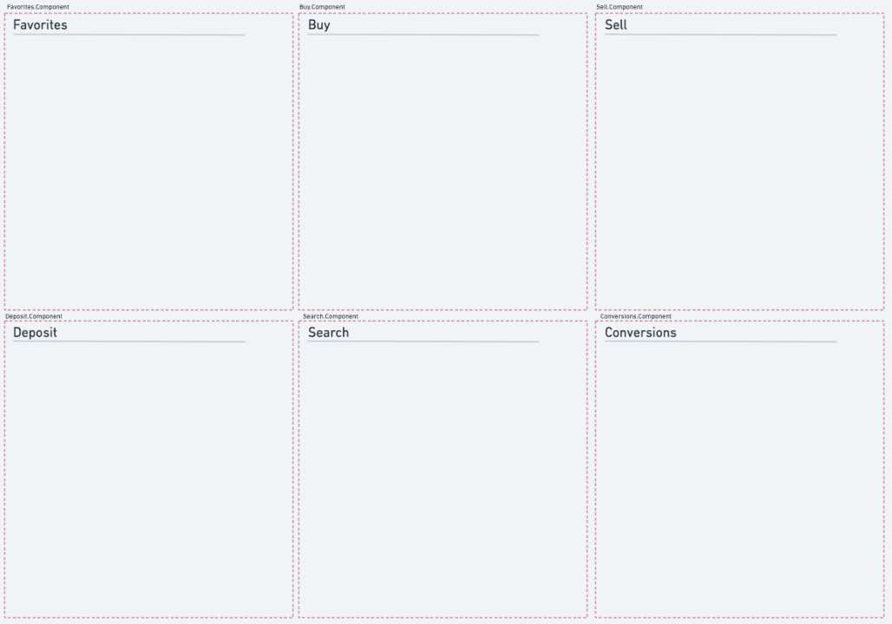

## Milestone Delivery

#### Milestone 1

**Accomplishments**

* Finalized desired application
* Use cases and personas easily applied to what we wanted to build
* Found easy to use external data source
* Great team collaboration via Slack and Google Hangouts

**Challenges**

* We had an initial direction we wanted to start with when we found an external data source through the BetterDoctor API, which provided a rich data set and seemed easy to work with. However after playing around with it in our first meeting we were unable to get multiple API keys to work, so we decided to abandon this idea rather than wait for their support and had to change direction of the application.